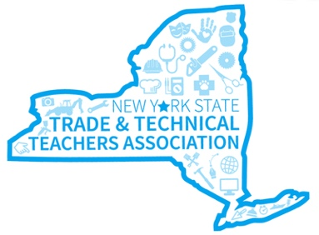
NY State Trade & Technical
Teachers Association

Statewide Cosmetology Teachers Collaboration Event
June 16, 2023 - OHM BOCES New Hartford, NY

AGENDA
Registration
9:00 – 9:30 AM

Welcome / Overview
10:00 – 10:15 AM
Brenda Moore – NYSTTTA President

NYSED Updates
10:15 – 10:45 AM
Nicole Hadsell - Shampoo Certificate, Middle Level CTE, Technical Assessments,
Teacher Certification updates, Employability Profiles

CTE Technical Assistance Center Updates
10:45 - 11:15 AM
Mike Woods -

Sharing Best Practice – Work Based Learning
11:15 – 12:00 PM
Round Table Discussions – Tables assigned

Lunch sponsored by
12:00 – 12:45 PM

Statewide Collaboration – Topics TBD
12:45 – 2:15 PM
Group Discussions on how to address the changes we are facing with students today

Report Out and Next Steps
2:15 – 3:00 PM
Each discussion group shares ideas from their table discussions

NYSTTTA Members - Annual Meeting and Election of Officers
3:00 – 3:30 PM

